**EXCEPTION HANDLING**

What factors affect the resale value of a car?

**Here are a few factors that go into determining a used car trade-in value.**

* The Age of Your Trade-In. ...
* The Mileage on Your Trade-In. ...
* The Overall Condition of Your Trade-In. ...
* The History of Your Car's Maintenance. ...
* The Equipment in Your Car. ...
* Current Demand Dictates the Deal.
* Make a Good Impression at Trade-In Time.

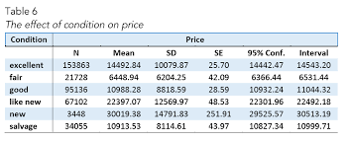

Which appear to be the three or four most important car specifications for predicting the car's price?

Which appear to be the three or four most important car specifications for predicting the car's price? Based on our decision tree vector; **Age, Auto AC, KM, and Quarterly Tax** seem to be the top predictors of car price. NOTE: Your results may vary based on your random seed selection.

What are the 5 things you should consider when purchasing a vehicle?

**5 Tips for Buying a New Car**

* Find Out the Cost of Insurance.
* Look for Safety Technology.
* Consider Vehicle Design and Size

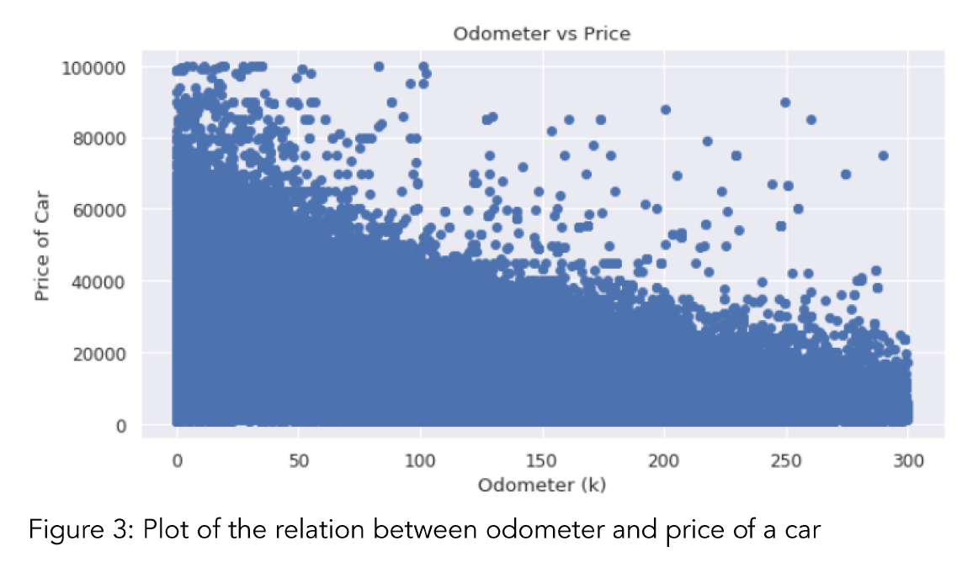

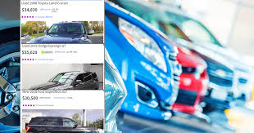

Which model is best for prediction?

**The most widely used predictive models are:**

* Decision trees: Decision trees are a simple, but powerful form of multiple variable analysis. ...
* Regression (linear and logistic) Regression is one of the most popular methods in statistics. ...
* Neural networks.
* Which car value estimator is most accurate?
* Since 1926, Kelley Blue Book has been one of the most trusted names in the auto industry. You might say we literally "wrote the book on car values". And today there's no better place to find the value of your.